**Question 1:**

**Python code for blinking LED using raspberry pi** import RPi.GPIO as GPIO from time import sleep

GPIO.setwarnings(False)

GPIO.setmode(GPIO.BOARD)

GPIO.setup(8, GPIO.OUT, initial=GPIO.LOW) while True:

GPIO.output(8, GPIO.HIGH) sleep(1)

GPIO.output(8, GPIO.LOW) sleep(1)

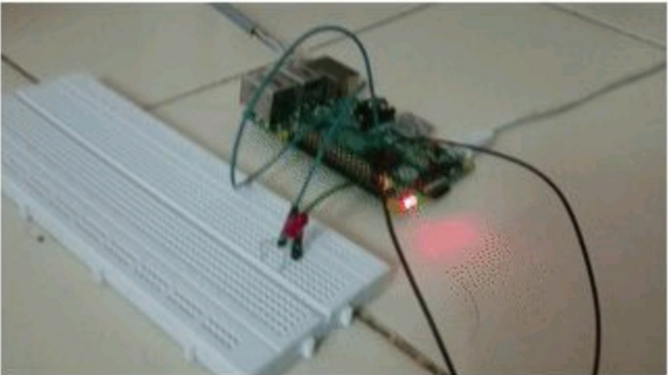

**Question 2:**

**Python code for traffic lights using raspberry pi** from gpiozero import Button, TrafficLights, Buzzer from time import sleep buzzer = Buzzer(15) button = Button(21) lights = TrafficLights(25, 8, 7) while True: button.wait_for_press() buzzer.on() light.green.on() sleep(1) lights.amber.on() sleep(1) lights.red.on() sleep(1) lights.off() buzzer.off()

